AI Use Declaration Form
Course: Introduction to Artificial Intelligence
Lab Title: Lab 1 — Uninformed and Informed Search Algorithms
Student Name: ___Amissah-Arthur Ewurabena Pinkra________________________________________________
Student ID: _________13112028_____________________________________________
GitHub Repository Link: ___________________________________________
Date Submitted: ______20th June, 2026____________________________________________

1. AI Use Summary
Question | Student Response
Did you use any AI tool for this lab? | Yes please
Estimated percentage of the work influenced by AI | % 15
Did you attach evidence of AI use where applicable? | No please

2. Details of AI Use
Complete the table below for each AI tool used. Add more rows where necessary.
Name of AI Tool Used | Purpose for Using the Tool | Prompt or Instruction Given to the Tool | Part(s) of the Work Influenced by the Tool | How I Verified, Edited, or Improved the AI Output
Claude | Debugging of some errors I suffered with | Debugging of code | Part A and B

3. Attachment of AI Output Evidence
Where required, attach evidence of AI use. Tick all that apply. Add more rows where necessary.
Evidence Type | Attached? (Yes, No, N/A) | File Name
AI-generated draft | N/A
Prompt history | N/A
Screenshot of AI interaction | Yes
Exported AI conversation | Yes
AI-generated code snippet | Yes
Revised version showing student input | Yes

4. Student Declaration
I declare that:
Declaration Statement | Response (Yes/No)
The submitted work is my own work. | Yes
Any use of AI tools has been clearly declared in this form. | Yes
The prompts, instructions, and AI-generated outputs have been disclosed where applicable. | Yes
I reviewed, tested, edited, and improved any AI-generated content before submission. | Yes
My AI usage does not exceed 25% of the entire work. | Yes
I understand that undeclared or excessive AI use may be treated as academic misconduct. | Yes

Student Signature: _____________________________E.P.A.A______________
Date: _________________________20th June, 2028__________________
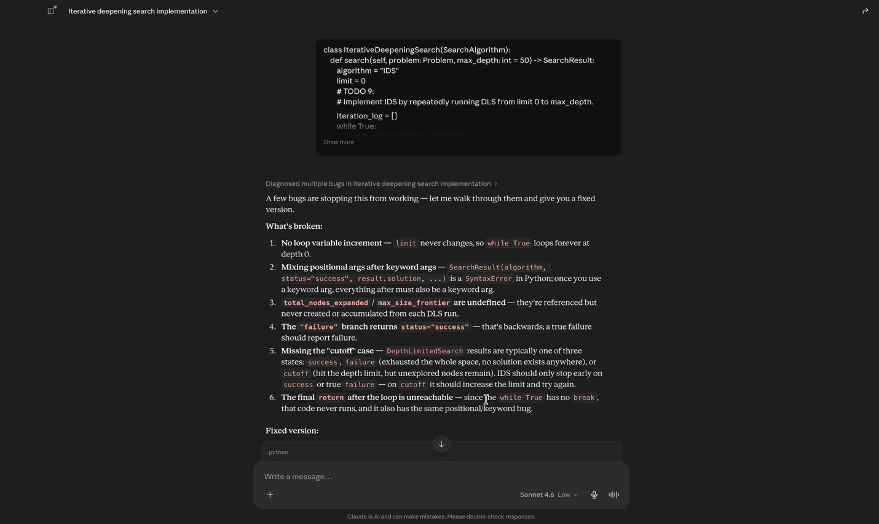
Importation of Debugging asking of my codes

